THM 415 Finance
Formulae Sheet Paper
Final Exam
Chapter 9
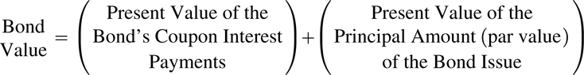
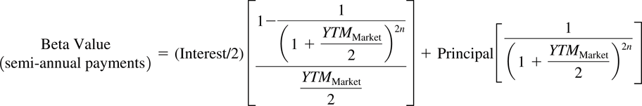
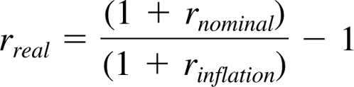
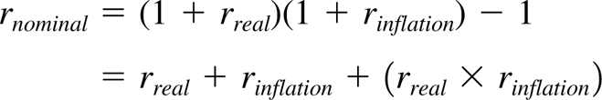
Chapter 11
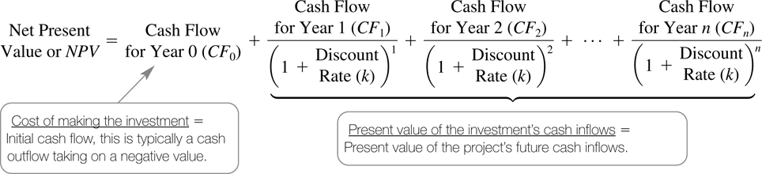
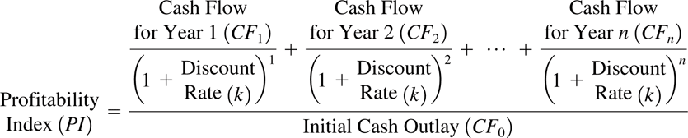
Chapter 12
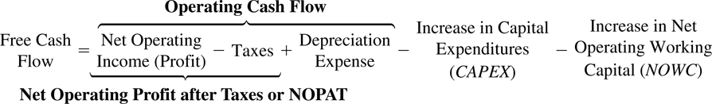
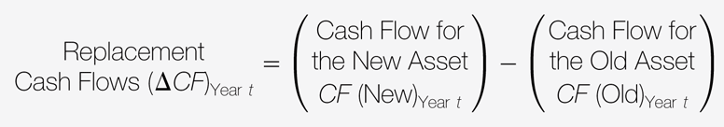
Chapter 14
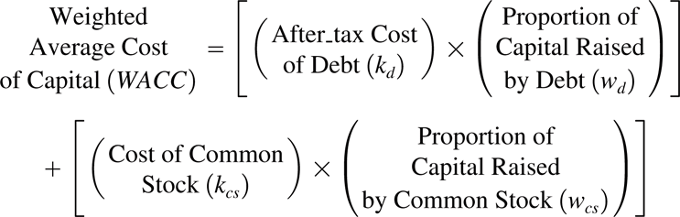
After-tax cost of debt = Yield (1 - tax rate)
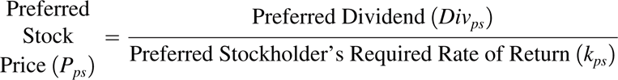
Cost of Common Equity (Dividend Growth Model):
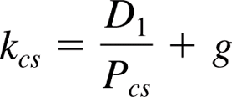
Cost of Common Equity (Capital Asset Pricing Model):
